**A Project Report**

**On**

# **“FIRE EVACUATION IN BUILDING”**

In the partial fulfillment of the requirement for Bachelor Degree in Civil Engineering

**Submitted by**

**Shinde Tejas Tanaji**

**Korhale Vikram Dattatray**

**Guided By**

**Prof. R. B. Matkar**



**DEPARTMENT OF CIVIL ENGINEERING**

**TSSM’S PADMABHOOSHAN VASANTDADAPATIL INSTITUTE OF TECHNOLOGY BAVDHAN, PUNE-21**

**SAVITRIBAI PHULE UNIVERSITY OF PUNE 2020-21**.

**TSSM’S**

**PADMABHOOSHAN VASANTDADA PATIL INSTITUTE OF TECHNOLOGY,**

**BAVDHAN, PUNE -21**

**SAVITRIBAIPHULE UNIVERSITY OF PUNE**



**CERTIFICATE**

This is to certify that the following student have satisfactorily carried out their B.E. project work entitled **“FIRE EVACUATION IN BUILDING”**. This work is being submitted for the award of degree of Bachelor of Civil Engineering. It is submitted in the partial fulfillment of the prescribed syllabus of Savitribai Phule Pune University, Pune, for the academic year 2020 – 2021.

Examination Seat No.: Name of students:

Tejas Tanaji Shinde

Vikram Dattatray Korhale

Prof. R. B. Matkar Dr. R. R. Sorate

**Guide H. O. D. Civil**

Dr. C. M. Sedani

**Principal External Examiner**

**ACKNOWLEDGMENT**

I wish to express my deep sense of gratitude towards my guide **Prof. R. B. Matkar (Civil Engineering Department)** for giving me an opportunity to work on this topic. They have always encouraged me with new ideas & helped me to develop interest in this field. There valuable inputs, precise guidance, unremitting encouragement & vigilant supervision were instrumental in carrying out this topic.

I would also like to thank **Dr. C. M. Sedani (Principal, PVPIT)**, **Dr. R. R. Sorate (H.O.D. Civil Engineering Department, PVPIT)** & all Civil Engineering faculties for their kind advice & support. I also thankful to my parents for their moral support, motivation & encouragement. Thank you.

Shinde Tejas Tanaji

Korhale Vikram Dattatray

**ABSTRACT**

More and more high rising buildings emerged in modern cities, but emergency evacuation of tall buildings has been a worldwide difficult problem. In this project, a new evacuation device for high rising building in fire accident was proposed and studied. This device mainly considered of special spiral slide ways and shunt valve. People in this device could fast slide down to the first floor under gravity without any electric power and physical strength, which is suitable for various emergency evacuation including mobility impaired persons. The plane simulation test has shown that human being in alternative clockwise and counter clock wise movement will not become dizzy.

The evacuated people should wear protection pad, which can prevent slider from being injured by surface friction with the slide, and eliminated the friction coefficient difference caused by different clothes and slide surface. The calculation result show that the evacuation speed of the new device is much faster than traditional staircases. Moreover, such new evacuation device can also be used as a means of vertical transportation in high- rise building partly. People can take it from any floor to ground floor directly, which not only save time for waiting for the lifts but also save the power. The new evacuation system is of simple structure, easy to use, and suitable for evacuation and partly used as vertical downwards traffic, which shows light on solving world-wide difficulties in fast evacuation in high-rise building.



FIRE EVACUATION IN BUILDING

## CHAPTER 1 INTRODUCTION

* 1. **Introduction**

An Escape chute is a special kind of emergency exit, used where conventional fire escape stairways ate impractical. The chute is a fabric (or occasionally metal) tube installed near a special exit on an upper floor or roof of a building, or a tall structure. During use, the chute is deployed, and may be secured at the bottom by a firefighting crew some distance out from the building. Once the tube is ready, escapees enter the tube and slide down to the lower levels or the ground level. Escape chutes can be used from most high areas, where there is a possibility of being trapped by fire, Terrorism, Criminal attack, or Industrial accident that could result in the loss of life serious injury due to no alternative means of emergency egress being available.

Escape chute system believe that the standard means of emergency egress (the internal stairway) should always be the used to egress the building in an emergency, however if that means of egress is impassable what then? Initially developed in the Sixties and Early Seventies by Gerard Zephaniah (Vertical Escape Chute) and the Uyeda Escape Chutes of Japan (Spiral and Inclined Escape Chute), Escape Chutes today are becoming an accepted alternative means of emergency evacuation from high rise buildings and industrial plant.

Escape chutes are now available in various formats, that allow evacuees to descend vertically down as in our “Vertie-Scape” escape Chute, or you can slide down at an incline as in our “Slide-Scape” both are a proven methods of emergency evacuation. Here are other formats of Escape Chutes on the market, which include an inclined nylon netting type, an inclined chute with spring reinforcement, and there is chute that are vertical, where the user travels down in an internal spiral, and as a result of public knowledge knowing that the consequences of not having an alternative method of emergency egress, there are more concepts and designs of systems being placed on the open market.

All escape chutes are an effective alternative method of evacuating a high location when all other means of emergency egress are blocked, the alternative to this alternative does not bare



FIRE EVACUATION IN BUILDING

thinking about, just one Escape Chute can evacuate at the rate of 25 people per minute, or have 360 persons at ground level in 15 minutes, irrespective to the height.

Escape Chute systems design and manufacture Mass and Rapid Emergency Evacuation Systems for: -

* + 1. Government Buildings,
    2. Petro Chemical Plants,
    3. Personal Safety,
    4. School,
    5. Aged Care Homes,
    6. Fire Rescue Departments,
    7. Rescue Organizations,
    8. High Rise Building,
    9. Embassies,
    10. Mining Equipment,
    11. Air & Seaways Traffic Control Tower,
    12. Banks,
    13. General Industry Cranes, Repair Tower,
    14. Hospitals, etc.

And any other structure where a human being can be trapped with no alternative means of emergency evacuation.

### “Vertie -Escape” Chute-

“verti-Escape”, the vertical Escape Chute is a device which aids in the mass and rapid evacuation of people from high structures, where one chute is capable of evacuating some 375 evacuees from a high rise building in 15 to 20 minutes. Where possible Escape Chute as an alternative means of emergency egress, however should the stairwell be blocked, or full of smoke, then a fast and efficient alternative means of emergency evacuation are Escape Chutes. The escape Chute can be used by people with disabilities and after a little training blind people are more than capable of using the chute, it is also possible for a person to enter the chute, and



# FIRE EVACUATION IN BUILDING

then have an injured second person placed upon their shoulders, to assist the second person to evacuate. The Escape Chute can be installed onto most structure, and only requires a clear drop from the evacuation point to ground level.

The Vertical Escape Chute when deployed runs parallel with the side of the structure from which it was deployed, and can use immediately after deployment. As you travel through the Escape Chute you can look up, and down, no smoke can enter the Chute. To exit your feet will touch the ground, you then crouch and extra your body from the Chute and walk away.

### How a Vertical Escape Chute Works-

Is manufactured from three completely separately and distinctly different fabric Tubes/Chute. Each Tube/Chute has its own function to perform, and it is only when these tree Tubes/Chute are assembled together do they then become an Escape Chute. The outer layer of the escape chute [Dark Grey] is there to protect the users from flame and radiated heat, it can withstand a constant temperature of between 550 & 600° C, and melts at around 810° C. Note the gap between the outer layer and the middle/braking layer, this allows air to circulate between the two tubes, thus preventing heat transfer. The middle/breaking layer [Light Gray] is the layer that makes the system work, it is an elasticated tube which is approximately 300mm in diameter in its rested form, but has the capability to expand to 600mm as the evacuee travels through, as the evacuee applies outward pressure from within the Chute, the evacuee slows down, as they release pressure they speed up, the evacuee has full control of the speed at which they descend.

The inner/support Chute (Being) gives the system its strength to hold the weight of the all-chute users with the chute at any one time, this layer has loops stitched into the top, into which we insert a stainless steel rolled pipe. The pipe is then held in place by the deployment device, or into a recess set into the floor in the case of multi-entry system. To use the escape Chute, the user sites on the edge at the entry point, with their feet and lower legs in the chute, at this point you will feel the escape chute grip your lower, legs, expand legs in the chute, and you will feel considerable resistance. While supporting your body weight yourself into the chute, keeping your legs fully extended against the inside wall of the chute. Once your shoulders are into the chute, push your hands and arms against the wall of the chute, this action and the bending of your legs



at the hips will bring you to a stop. By relaxing the pressure against the wall, you will then descend.

### Civil and MEP Requirements -Multiple Escape Chute System: -

The Slab design becomes extremely important in the present scenario where modern techniques such as Mivan and Mascon are used in building construction. These systems while being extremely efficient are much less flexible in terms of incorporating changes once the slabs have already been cast. Hence it is very important to know the exact slab design before the slab is actually cast. Shown below is the detailed plan and sectional view of the SQUARE cut out required in every ALTERNATE mid-landing slab in the Fire Escape Chute Duct. Slabs are required on only ALTERNATE Mid landings.

The Cut out in the Slab will be a Square cut out of size 660 X 660 Void and a 75 mm deep step on the upper side of Dimension 720X720 (as shown in the Drawing below) There should be no wall, beam or any obstruction anywhere within a radius of 550 mm from the Centre of the Cut out.

Relax Pressure = SPEED UP. Increase Pressure = SLOW DOWN

### By applying enough pressure, you can come to a complete stop, and just sit there!

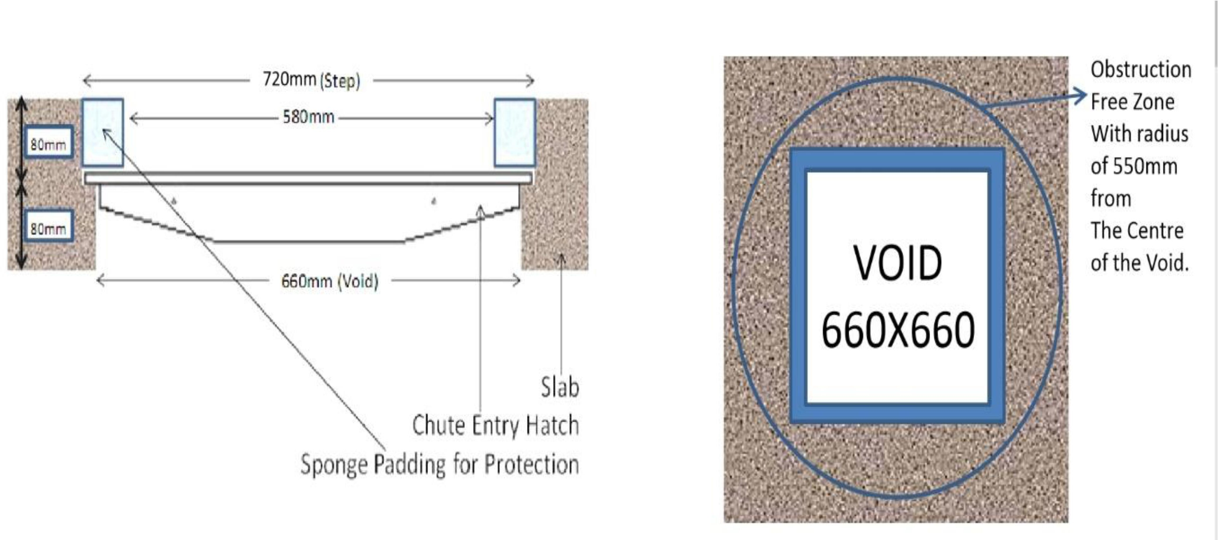

**Fig.1:**



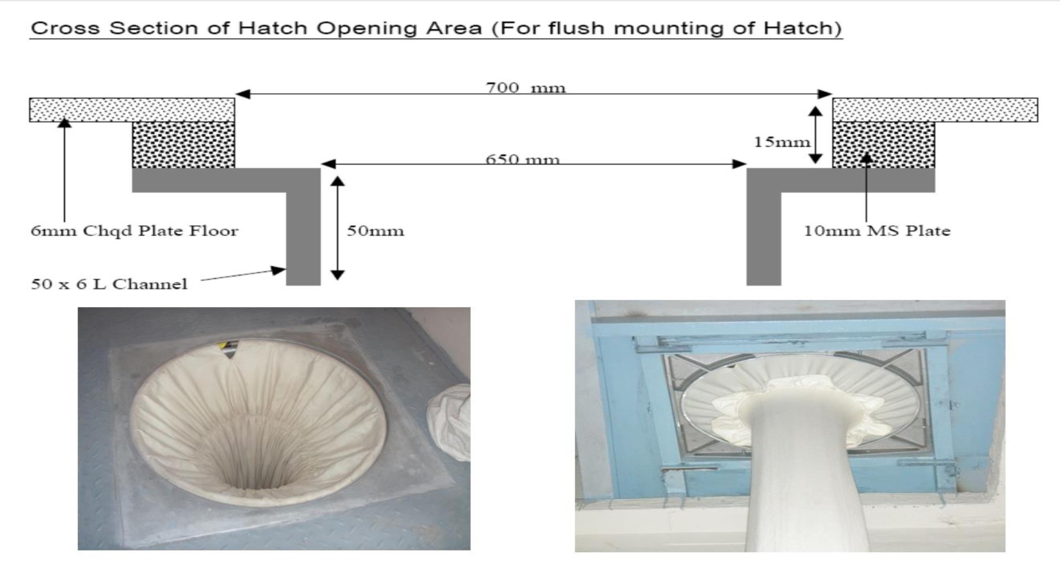

**Fig.2 (a) Metal Floor Deck**

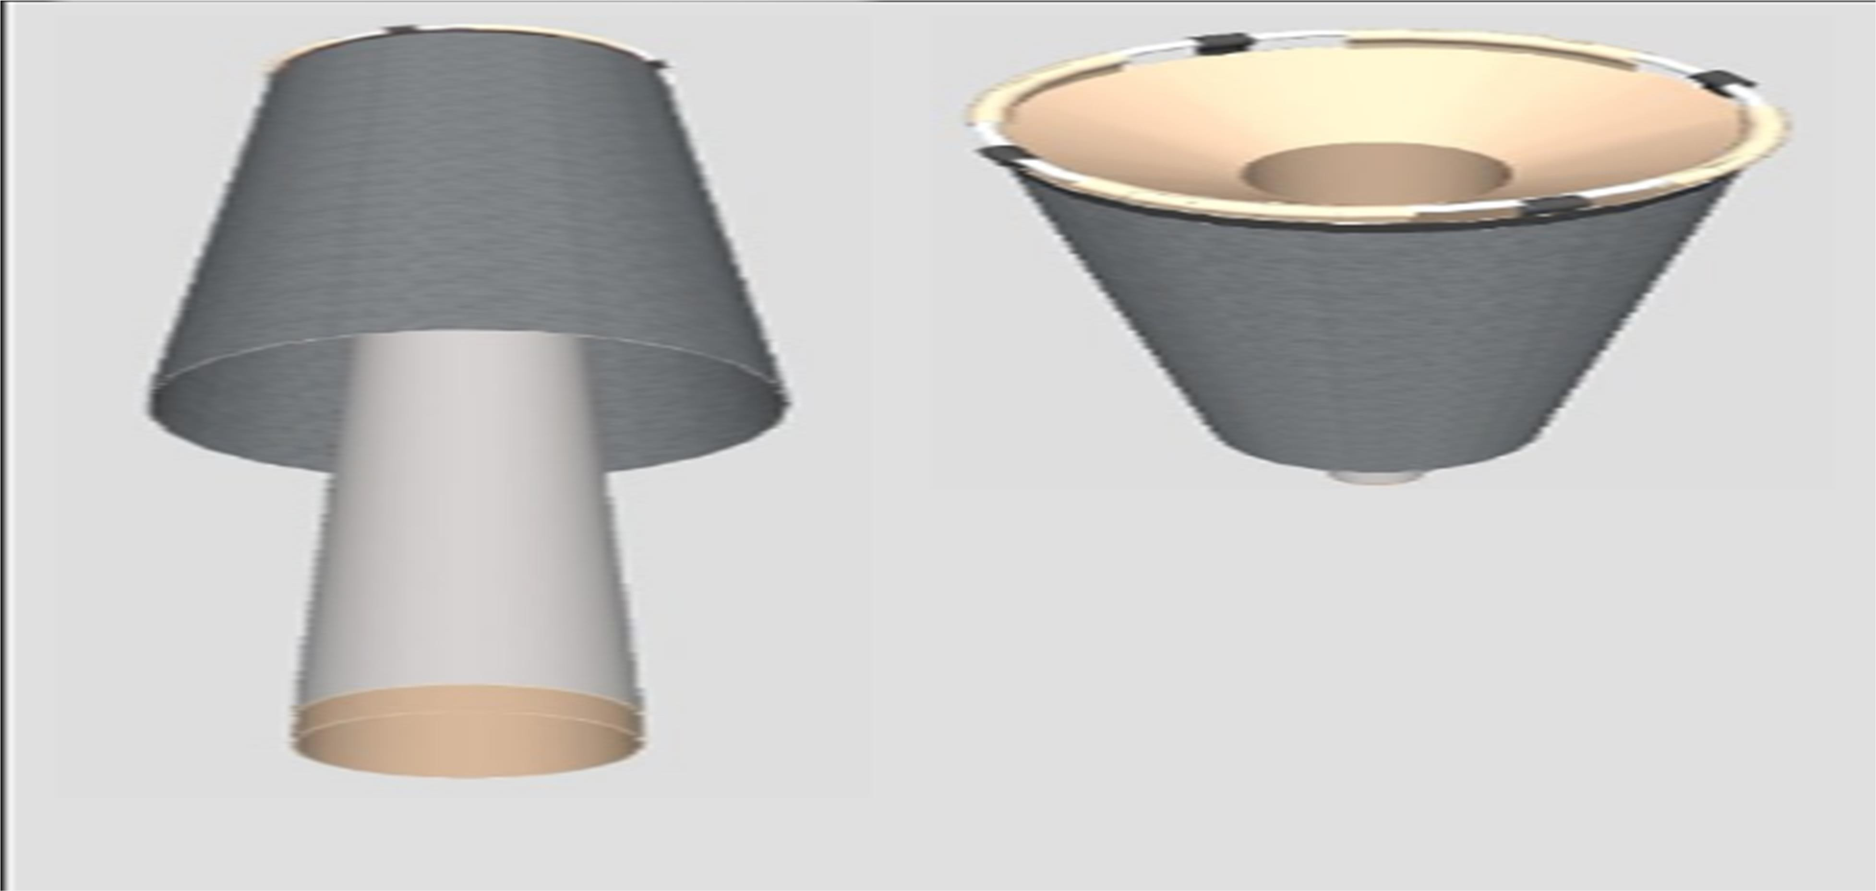

**Fig.2 (b) Component part of Fire Escape Chute**



### HISTORICAL BACKGROUND

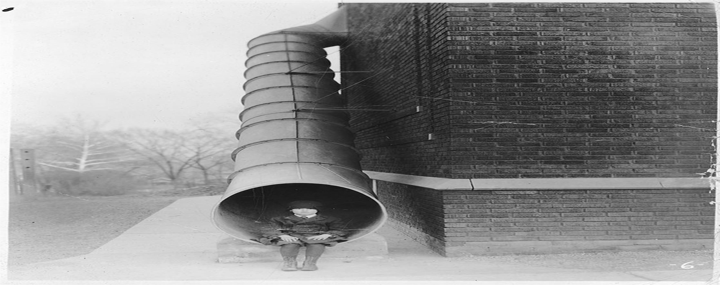

**Fig.3 A small child is sitting in the End of the chute that allows Escape from the second story Of a brick building**

In Canada, metal tubes were installed on school building in the1800s, including the original Alexander muir public school, at prospect and timothy streets in new market, Ontario.

In 1948, the 136-bed Georgia Baptist Hospital in Atlanta featured a large fabric escape chute that was claimed to be able to empty the hospital “in only a few minutes”

An Escape Chute system was installed at the Cape Canaveral launch pads for the now- discontinues NASA Space Shuttle, to allow personnel to rapidly reach a safety refuge blast shelter in the event of an imminent fire or explosion.

## Need of Escape Chute-

* Saves lives!
* Protects property by facilitating a speedy response to emergencies
* Ensures peace of mind for tenants, employers, owners and building management
* Provide effective and guaranteed means of escape for hospital bedridden patients or people with mobility problems, form any floor of a hospital, regardless of their mobility impairment.



# FIRE EVACUATION IN BUILDING

* 1. **Objectives**

The overall objective of this work is not only a literature review of human behavior and modeling studies in the case of high-rise building evacuations. This review was a necessary step in a larger research project aimed at studying high-rise building egress strategies including both vertical and horizontal egress components by means of egress modeling.

A set of specific objectives are also defined and they correspond to:

* Identify the key behavioral factors affecting the performance of people during a fire in a high-rise building, the singularities associated to this type of buildings and areas of future research.
* Review the procedures and strategies currently adopted in high-rise buildings (e.g., horizontal and vertical evacuation methods, phased evacuation, total evacuation, defend- in-place, etc.).
* Review and analyze the capabilities of evacuation models by reviewing their current characteristics and applications in the context of high-rise building evacuations.



FIRE EVACUATION IN BUILDING

**CHAPTER 2 LITERATURE REVIEW**

* 1. **Literature Review**
     1. **STUDY ON RAPID EVACUATION IN HIGH-RISE BUILDINGS**

**Xin Zhang,** Shanghai Xiandai Architectural Design Group, East China Architectural Design & Research Institute Co., China

**From**- Engineering Science and Technology, an International Journal journal homepage: [www.elsevier.com/locate/jestch](http://www.elsevier.com/locate/jestch) [ON DATED- 12 MAY 2017]

More and more high rising buildings emerged in modern cities, but emergency evacuation of tall buildings has been a worldwide difficult problem. In this paper, a new evacuation device for high rising building in fire accident was proposed and studied. This device mainly considered of special spiral slide ways and shunt valve. People in this device could fast slide down to the first floor under gravity without any electric power and physical strength, which is suitable for various emergency evacuation including mobility impaired persons. The plane simulation test has shown that human being in alternative clockwise and counterclockwise movement will not become dizzy. The evacuated people should wear protection pad, which can prevent slider from being injured by surface friction with the slide, and eliminated the friction coefficient difference caused by different clothes and slide surface. The calculation result show that the evacuation speed of the new device is much faster than traditional staircases. Moreover, such new evacuation device can also be used as a means of vertical transportation in high- rise building partly. People can take it from any floor to ground floor directly, which not only save time for waiting for the lifts but also save the power. The new evacuation system is of simple structure, easy to use, and suitable for evacuation and partly used as vertical downwards traffic, which shows light on solving world-wide difficulties in fast evacuation in high-rise building.

### NEW FRAMEWORK OF INTELLIGENT EVACUATION SYSTEM OF BUILDINGS



FIRE EVACUATION IN BUILDING

**Qian Zhanga,** Tao Chenb, Xian-zhi LVa a Kunming firefighting Command Schppl, Kunming.

**From-** Homepage- [www.sciencedirect.com](http://www.sciencedirect.com/) 1877-7058©2014 published by Elsevier

On the basic of the analysis about the traditional evacuation and lifesaving facilities, this paper adopts high-tech technology means [e.g., advanced intelligent information-monitoring technique, artificial intelligent technique, computer technology, etc.], integrates the function of building evacuation, and establishes an intelligent evacuation system. This system overcomes the disadvantages and defects of the current intelligent evacuation system, and realizes the intelligent dynamic guidance of the intelligent evacuation system. It aims to actually realize the intellectualization according to the dynamic change of the fire scene, and make the personal evacuation more scientific, rapid and safer. ©2014 The Authors Publish by Elsevier Ltd. Selection and peer-review under res.

### 2.1.3 STUDY ON NEW ESCAPE CHUTE DEVICE OF HIGH-RISE BUILDING

**Yao Yansheng** School of mechanical and electrical engineering Anhui University of Architecture, China homepage- [WWW.ys@163.com](mailto:WWW.ys@163.com)

Safe escape in the fire disaster of high-rise buildings is a world-wide unsolved problem because of the complicated structure of the building and the huge amounts of resident. Nowadays the chute devices for escaping in high-rise building become important for collective escape, which is easy to use and runs at high speed without extra power. Rigid escape chutes and flexible escape chutes are introduced in this paper.

The assembly of escape chutes and their disadvantages are discussed. For more function and more effective, a flexible multi-entrance escape chute with its store box is designed. This device offers a fire-proof, high temperature-proof and multi-entrance passage for collective escapes at the same time. Experiments of its prototype shows that this equipment can release escape chute in time, and bring evacuee more safety and escape efficiency.

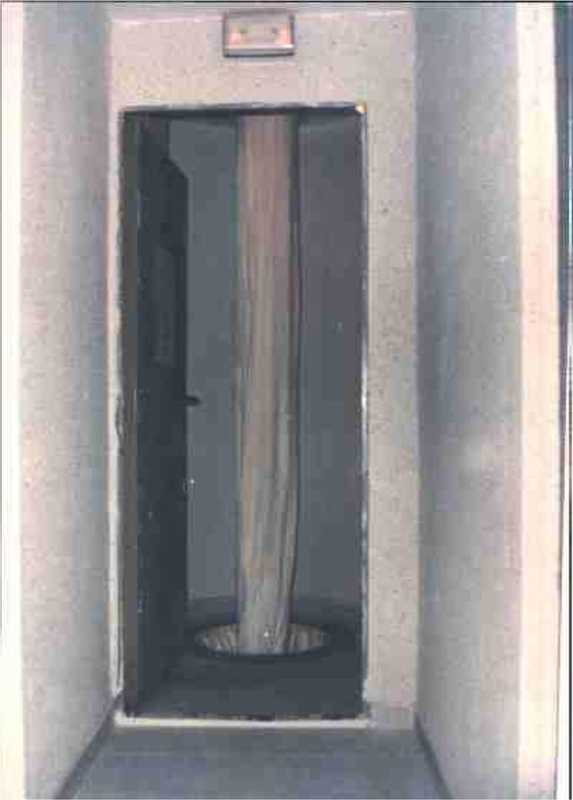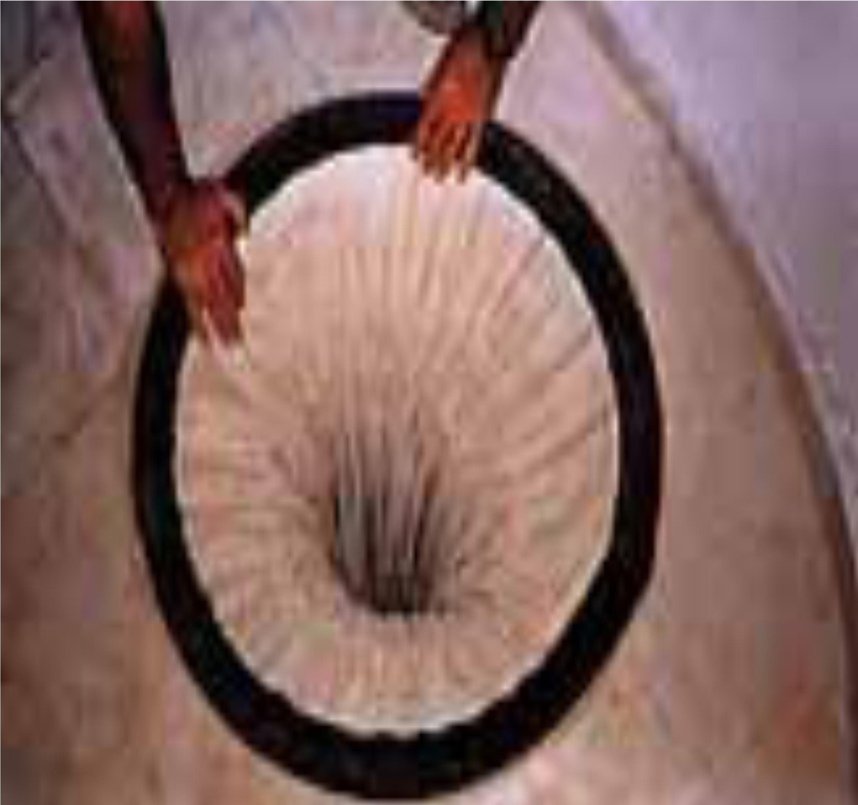



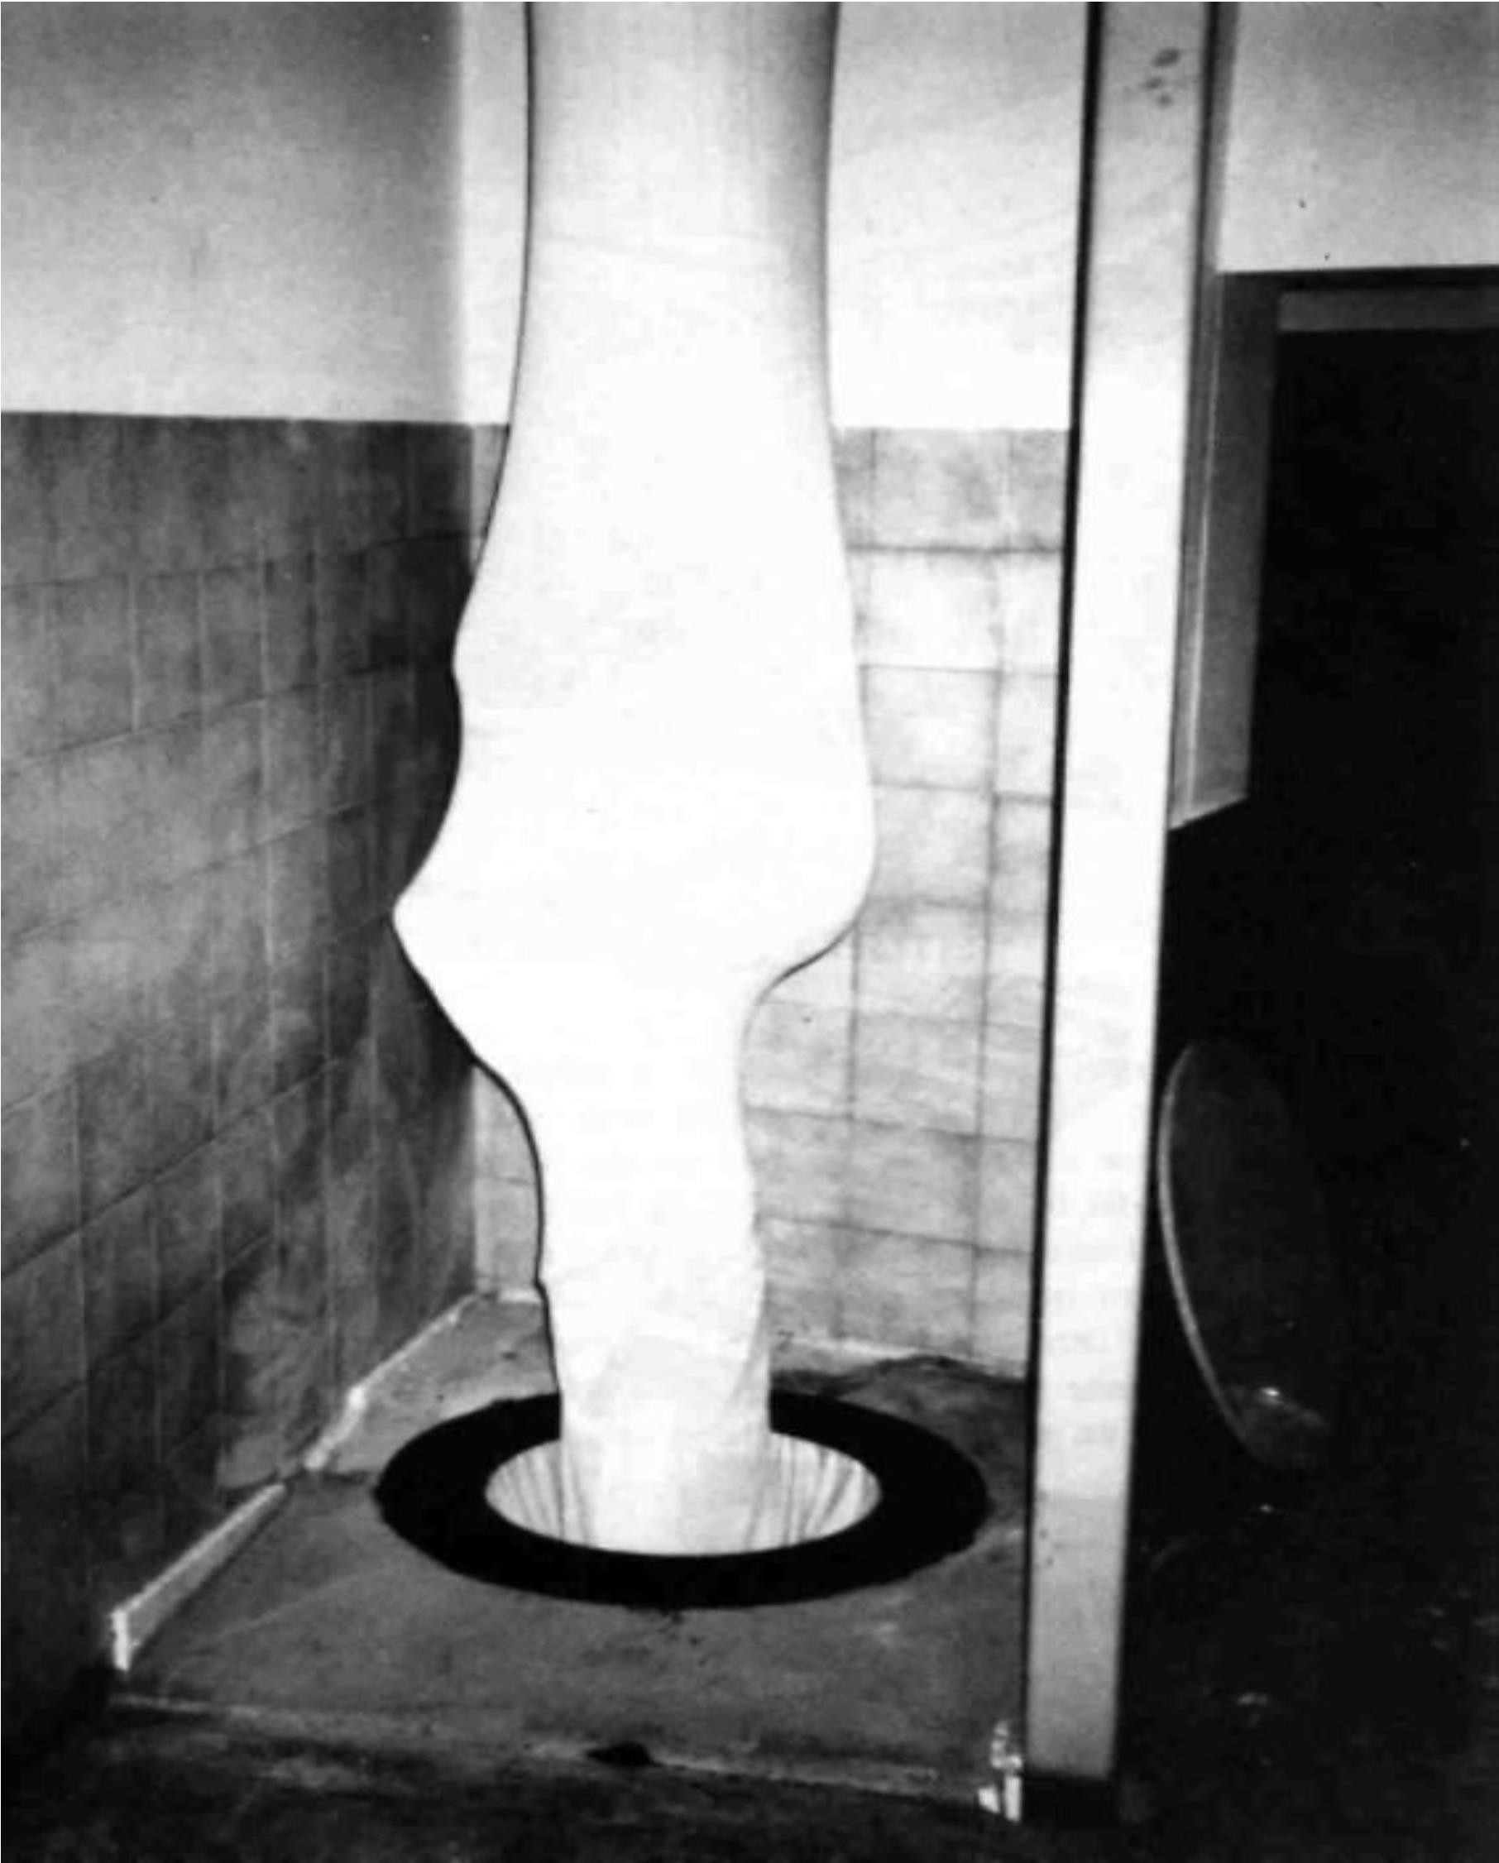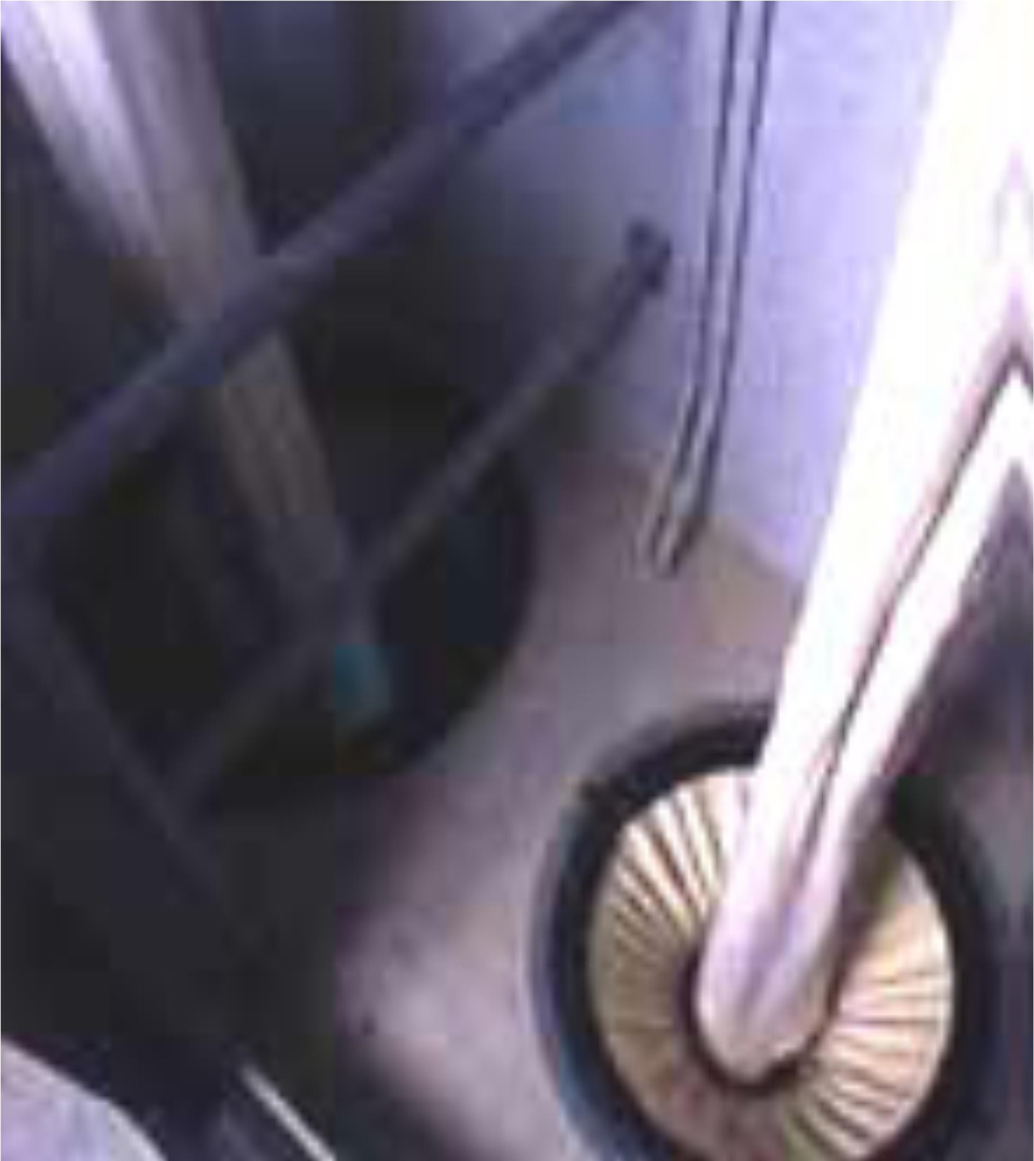**Fig.7 (b) Multi-Entry Escape Chute (Interior Egress**

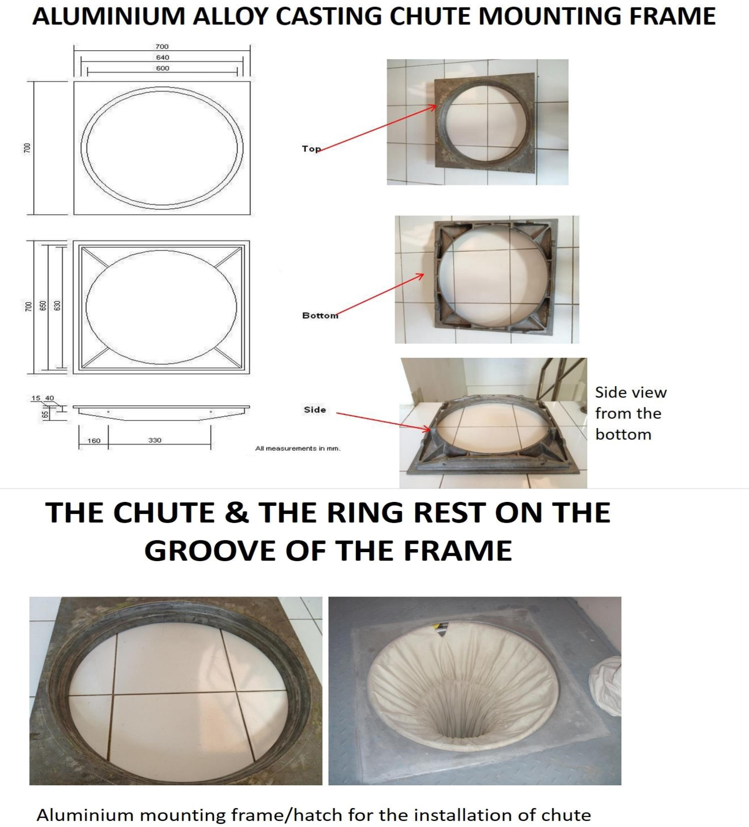

**Fig.11**



**CIVIL AND MEP REQUIREMENTS – INGSTROM MULTIPLE ESCAPE CHUTE SYSTEM**

**Concrete Floor**

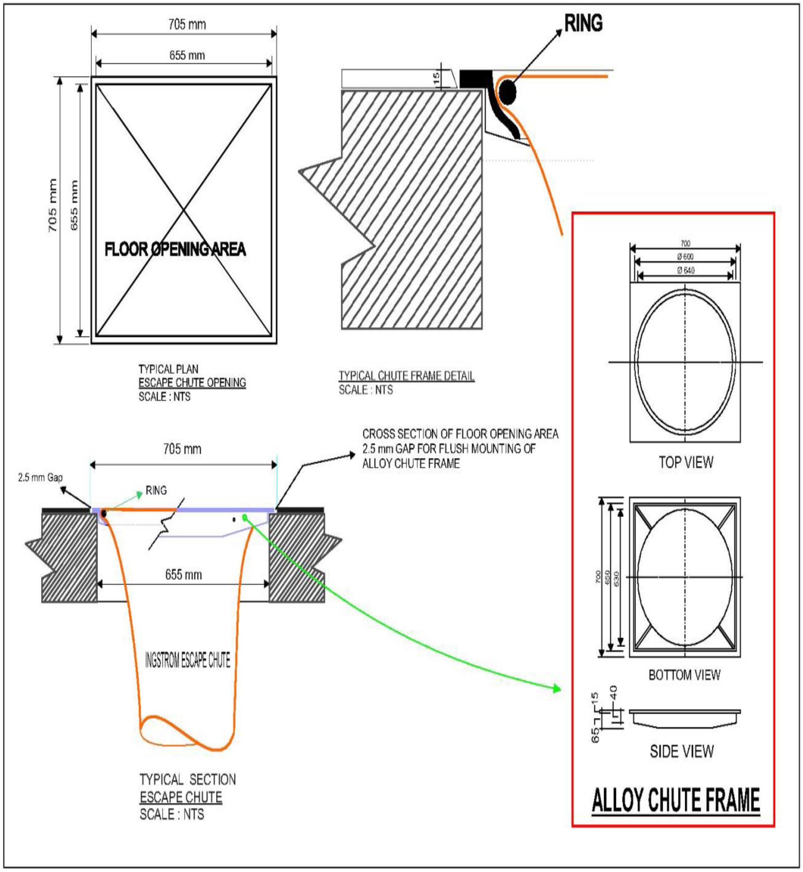

**Fig.12 Concrete Floor**

FIRE EVACUATION IN BUILDING

**5.1 Conclusion:**

**CHAPTER 5 CONCLUSION**



In summary, a new evacuation device is proposed and designed for high rise building evacuation, which mainly consist of special slide way and shunt valve, chute container and also the special spiral slide ways structures could avoid human dizziness during spiral motion. Protective pad and shunt valve can ensure the safety of people when they are quickly evacuated to the outdoor ground floor. Such device does not require any electric power and physical strength, with the feature of simple structure and easy to use; It can be used not only in the high- rise building emergency evacuation for all kinds of people, but also can replace some of the vertical transportation means. It shows advantages of saving power energy, reducing the number of elevators, and decreasing the total project cost. The application of this new evacuating equipment to high-rise building is expected to not only solve the quick evacuation problem for high-rise building in the world but also enjoy a certain amount of economic benefit. At the moment, it is only a proposal requiring justification and more experience will be conducted to investigate practical application of the new evacuation device. In the future research, investigations will be planned in order to consider the possibility of including emergency exits. We can also conclude from above topic is not only install at building structure the mobile equipment, at mining trucks, power shovels, also can be used at marine evacuation. From this topic we also conclude that the escape chute container is install at both sides of building.



# FIRE EVACUATION IN BUILDING

## REFERENCES: -

### STUDY ON RAPID EVACUATION IN HIGH-RISE BUILDINGS

**Xin Zhang,** Shanghai Xiandai Architectural Design Group, East China Architectural Design & Research Institute Co., China

**From**- Engineering Science and Technology, an International Journal journal homepage: [www.elsevier.com/locate/jestch](http://www.elsevier.com/locate/jestch) [ON DATED- 12 MAY 2017]

1. **NEW FRAMEWORK OF INTELLIGENT EVACUATION SYSTEM OF BUILDINGS Qian Zhanga,** Tao Chenb, Xian-zhi LVa a Kunming firefighting Command Schppl, Kunming.

**From-** Homepage- [www.sciencedirect.com](http://www.sciencedirect.com/) 1877-7058©2014 published by Elsevier

1. **STUDY ON NEW ESCAPE CHUTE DEVICE OF HIGH-RISE BUILDING**

**Yao Yansheng** School of mechanical and electrical engineering Anhui University of Architecture, China homepage- [WWW.ys@163.com](mailto:WWW.ys@163.com)

1. **Jönsson A, Andersson J, Nilsson D**: **A Risk Perception Analysis of Elevator Evacuation in High-Rise Buildings.** In *Proceedings of the 5th Human Behavior in Fire Symposium*. Interscience Communication Ltd, Cambridge, UK; 2012.

### Enrico Ronchi and Daniel Nilsson: - Fire evacuation in high-rise buildings: a review of human behavior and modeling research

**BOOK:**

* 1. Emergency Evacuation Planning For Your Workplace; From Chaos to Life-

Saving Solutions Hardcover- August 1, 2013

by J im Burtles (Author), K risten Noakes-Fry (Editor)

**Thank You.**